Phase checker
This calculator is used to let parents check which phase their child is eligible for during P1 registration.

The logic is structured into a flow and the answer to each question leads to different paths, using branching logic.

The answer card contains information based on the logic path taken.

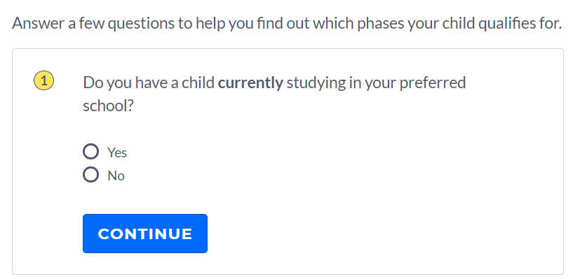

​Logic
This checker consists of Yes/No questions and Options.

The final display results are based on the selected option(s). There can be multiple phases in the results.

Phase Results | Selected Criteria
1 | You have another child currently studying at your preferred school.
2A | You are a member of the school alumni association and a former student of your preferred school.
2A | You are a member of the Advisory or Management Committee of your preferred school.
2A | You have another child who previously studied in your preferred school.
2A | You are a staff member of the school.
2A | Your child is currently in the MOE Kindergarten located within your preferred school.
2B | You are a parent volunteer at the school, joined not later than 1 July of the year before P1 registration and completing at least 40 hours of voluntary service to the school by 30 June of the year of P1 registration.
2B | You are a member endorsed by the church or clan directly connected to the school.
2B | You are endorsed as an active community leader.
2C | If your child is eligible for P1 and not yet registered in a primary school.

​There are 2 scenarios with one response.
- Phase 1 is immediately offered when the question “Do you have a child currently studying in your preferred school?” is answered Yes.
- Phase 2C is immediately offered when the option “None of the above” is selected. It is also a universal option offered to all selections except Phase 1.

Phases 2A to 2C are results derived from the list of selected options.
If there is more than 1 selection, there may be additional liners where the child is eligible for other Phases, according to how they are categorised.

E.g.: The selected options are “You are a member of the Advisory or Management Committee of your preferred school.”, “I am a staff member of my preferred school” and “I am endorsed as an active community leader.” The returned results will be “Phase 2A”, followed by an additional liner for “phases 2B and 2C”.
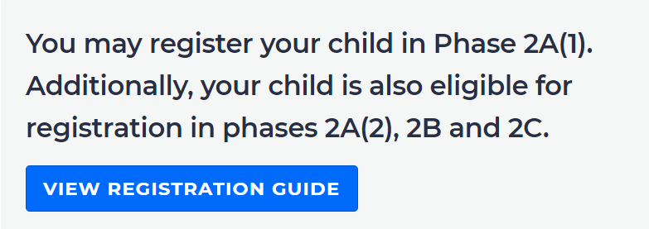

​Backend
The logic flow of the Phase checker can be configured in the backend by adding 2 elements: Question Card and Response Card. Each question card will determine the next step in the whole flow, either to another question card or to a response card for the result of the flow.

User can update the following fields for the Question Card:
- Question Label - free text; allows for easier recognition in the backend (i.e. internal) and will not be shown in the frontend (i.e. to the public)
- Question Text - RTE
- Response Types – selection for 2 options i.e. Yes/No and Multiple Selection Checkbox Response
  - Yes/No Response
    - Next path for each option - either to another Question card or to a Response card
  - Multiple Selection Checkbox Response
    - Selection Label (for each selection) - free text; public-facing (e.g. “I’m a member of the school advisory committee”, etc.)
    - Next path (for each selection) - either to another Question card or to a Response card
    - Next path for selection combination
      - Add different selection label together to form a combination
      - Next path (for the combination) - either to another Question card or to a Response card

User can update the following fields for the Response Card:
- Response Label - free text, allow for easier recognition in the backend (i.e. internal) and will not be shown in the frontend (i.e. to the public)
- Response Text - RTE
- Button Name - free text (Optional, only compulsory if link has value)
- Button Link - URL (Optional, only compulsory if name has value)

The table below is an example of how data for question and response cards can be input in the backend for each logic flow.
Logic Flow | Fields for user input |  |  | Format
P1 Phase Checker | Question Card
P1 Phase Checker | Question Label |  |  | Free text
P1 Phase Checker | Question Text |  |  | RTE
P1 Phase Checker | Response Type | Response Type selection |  | Dropdown  - Yes/No  - Multiple Selection Checkbox Response
P1 Phase Checker | Response Type | Yes/No Response Type
P1 Phase Checker | Response Type | Next path for each option |  | Dropdown  - Another Question card  - Response card
P1 Phase Checker | Response Type | Multiple Selection Checkbox Response
P1 Phase Checker | Response Type | Selection Label (for each selection) |  | Free text
P1 Phase Checker | Response Type | Next path (for each selection option) |  | Dropdown  - Another Question card  - Response card
P1 Phase Checker | Response Type | Selection combination | Configure selection combination | Multiple select listing  (to add from all available selections created within this question card)
P1 Phase Checker | Response Type | Selection combination | Next path (for the combination) | Dropdown  - Another Question card  - Response card
P1 Phase Checker | Response Card
P1 Phase Checker | Response Label |  |  | Free text
P1 Phase Checker | Response Text |  |  | RTE
P1 Phase Checker | Button Name |  |  | Free text
P1 Phase Checker | Button Link |  |  | URL

Below is how the data input will be shown and used in the frontend:
